**Comparison of Real and Synthetic Data Results**

The visualizations produced—both distribution plots and Spearman correlation heatmaps—provide insightful comparisons between the real and synthetic datasets. Let's break down the analysis of these results across the two types of plots.

**1. Distribution Comparisons**

The first set of visualizations consists of side-by-side distribution comparisons for five key variables: Mean Arterial Pressure (MAP/MeanBP), Systolic Blood Pressure (SysBP/systolic_bp), Diastolic Blood Pressure (DiaBP/diastolic_bp), Serum Creatinine (serum_creatinine), and Lactic Acid (Lactate/lactic_acid).

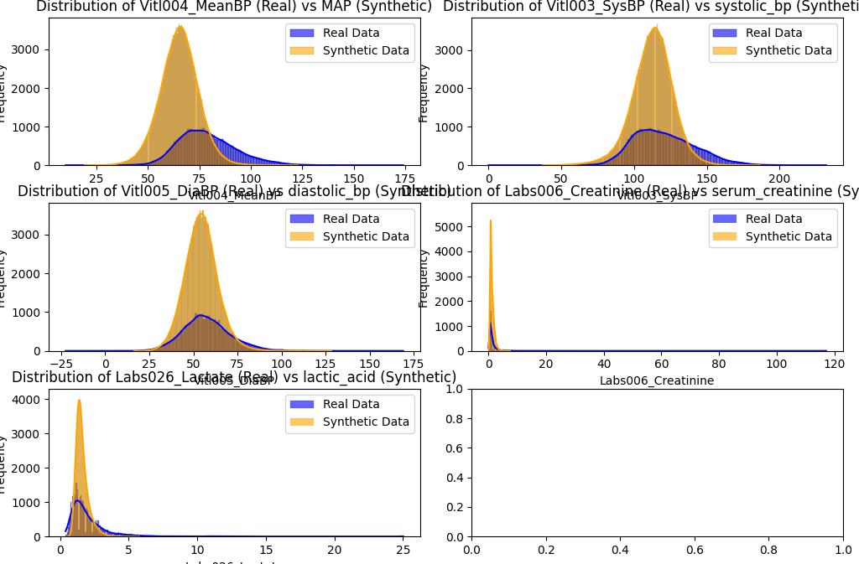

The blue histograms represent real data, while the orange histograms represent synthetic data. Here’s a variable-by-variable breakdown of the findings:

* **MAP (Mean Arterial Pressure)**

The distribution of MAP in the synthetic data closely resembles that of the real data. Both datasets display a similar bell-shaped distribution, indicating a Gaussian distribution around the mean. This implies that the synthetic data accurately mimics the overall trend and spread of MAP in the real dataset. However, there are slight discrepancies in the tails of the distribution, where the synthetic data exhibits higher variance and spread than the real data.

* **Systolic Blood Pressure (SysBP)**

In the case of systolic blood pressure, the synthetic dataset again follows the general pattern of the real data, but with more variance, particularly around the mean. The synthetic data appears to exaggerate the peak around the mean, while the real data has a slightly broader spread. This overfitting around the mean in the synthetic data suggests that while the model used to generate synthetic data has captured the basic distribution, it may not fully account for the natural variability in real-world systolic blood pressure measurements.

* **Diastolic Blood Pressure (DiaBP)**

Similar to systolic blood pressure, diastolic blood pressure exhibits a narrower distribution in the synthetic data compared to the real data. The real data shows a broader distribution, reflecting greater variability in real-world measurements. The synthetic data, on the other hand, has a sharper peak around the mean, potentially indicating that the synthetic generation method is slightly biased towards central values, not fully capturing the variability seen in actual patient measurements.

* **Serum Creatinine**

Serum creatinine levels show a clear divergence between the real and synthetic datasets. While the general shape is somewhat similar, the synthetic data exhibits a much wider spread, particularly at the tail ends. The real data shows a much more concentrated peak around lower creatinine values. This disparity suggests that the synthetic data may not accurately reflect the true distribution of creatinine values, especially for extreme or rare values. The real dataset likely represents more consistent patterns of creatinine distribution, while the synthetic dataset seems to exaggerate outliers.

* **Lactic Acid**

Lactic acid levels in the synthetic data are also quite different from the real dataset. Similar to serum creatinine, the synthetic dataset has a more spread-out distribution, with a less pronounced peak compared to the real data. The real data displays a much sharper peak at lower lactic acid values, while the synthetic data exaggerates values at both the low and high ends. This may indicate that the synthetic data generation process did not perfectly capture the real-world patterns of lactic acid concentration in patients.

**2. Spearman Correlation Heatmaps**

The second type of visualization compares the Spearman correlation matrices between the real and synthetic datasets.

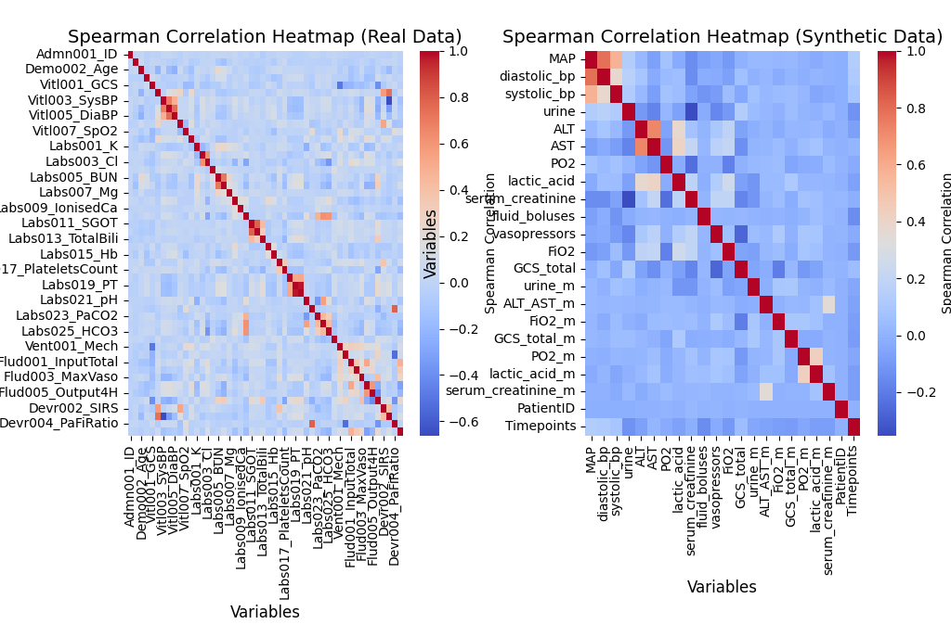

These heatmaps are color-coded to reflect the strength and direction of the correlations, with values closer to 1 or -1 indicating strong correlations and values near 0 representing weak or no correlations.

* **Real Data Heatmap**

The real data heatmap exhibits strong correlations between several variables, particularly among physiological metrics that are naturally correlated. For example, systolic and diastolic blood pressure show strong positive correlations, as expected in clinical settings. Other correlations, such as between various blood gas and metabolic indicators (e.g., lactate, creatinine, and glucose), are also visible and align with known medical knowledge about how these variables are related in real patient populations.

* **Synthetic Data Heatmap**

The synthetic data correlation heatmap, while broadly similar, shows weaker and more dispersed correlations between variables. Some of the expected strong correlations, such as between systolic and diastolic blood pressure, are present, but many other correlations are either weaker or not as well-defined as in the real data. For example, the correlation between serum creatinine and other metabolic variables is not as pronounced. This suggests that while the synthetic data generator has captured some of the key relationships between variables, it struggles to fully replicate the complex, multifaceted relationships seen in real clinical data.

**Explanation of Results: Real vs. Synthetic Data Comparison (individual indicators)**

in this analysis, we generated visual comparisons between the real and synthetic datasets, focusing on several key clinical indicators: Mean Arterial Pressure (MAP), Systolic Blood Pressure (SysBP), Diastolic Blood Pressure (DiaBP), Serum Creatinine, and Lactic Acid. The visualizations provided insights into how well the synthetic data replicates real-world variability and relationships between these physiological measurements across individual patients.

**1. Mean Arterial Pressure (MAP)**

In the comparison of MAP (MeanBP in the real data and MAP in the synthetic data), the real dataset shows significant variability across patients. The blue dots, representing real data, exhibit a wide range of values, particularly in the lower patient indices. This reflects the natural diversity in patients' blood pressure levels, where different health conditions cause varying levels of MAP.

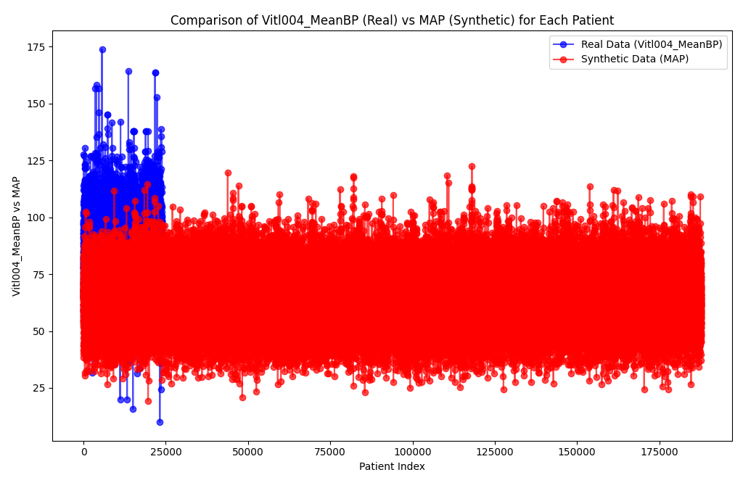

On the other hand, the synthetic dataset (red dots) shows a more constrained distribution. The synthetic data points are tightly clustered around a central value, with fewer extreme values than the real data. This suggests that the synthetic data generation process might not fully capture the natural variability in patients' MAP levels, particularly for patients with extreme conditions. The synthetic data appears to generalize the MAP range, reducing the number of outliers or patients with unusually high or low values.

**2. Systolic Blood Pressure (SysBP)**

In the systolic blood pressure comparison, a similar pattern emerges. The real dataset shows a wide spread of systolic blood pressure values, particularly among patients with higher indices (i.e., a wider range of blood pressures). This is expected in clinical data, as blood pressure can vary greatly depending on the patient's age, health status, and underlying conditions.

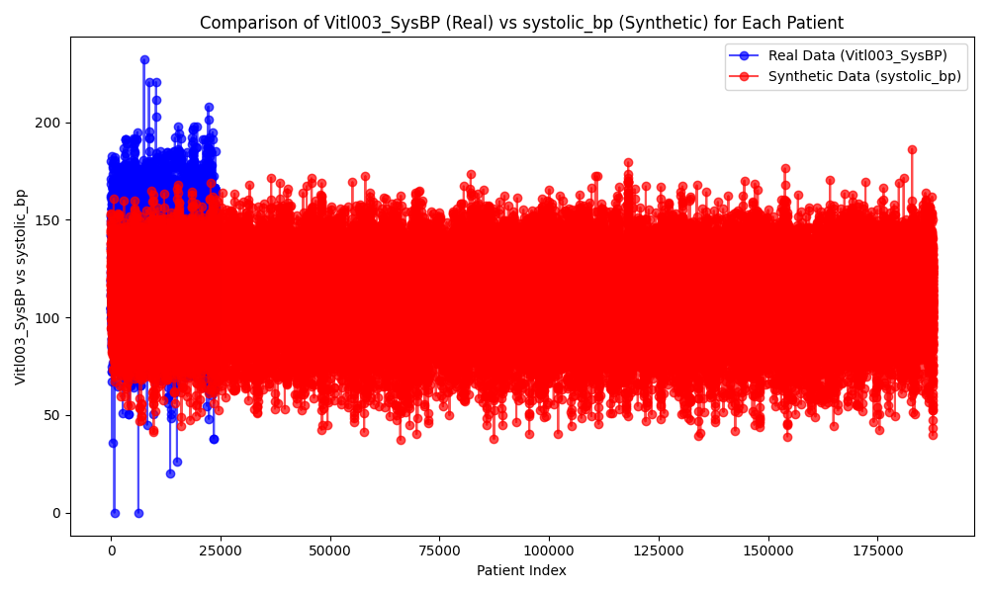

The synthetic data, however, displays a narrower range. Like in the MAP comparison, the synthetic systolic blood pressure values are more concentrated around a central value, with fewer extremes. This indicates that while the synthetic data does a reasonable job of approximating the average systolic blood pressure, it may not fully capture the natural variability seen in real patients. This lack of variability suggests the synthetic data might be missing important cases that are medically significant, such as patients with hypertension (high blood pressure) or hypotension (low blood pressure).

**3. Diastolic Blood Pressure (DiaBP)**

The diastolic blood pressure comparison reveals similar trends. The real dataset shows higher variability in patients' diastolic blood pressure levels, particularly among those with higher indices. The real data points exhibit more spread, representing the wide range of diastolic blood pressure values found in clinical populations.

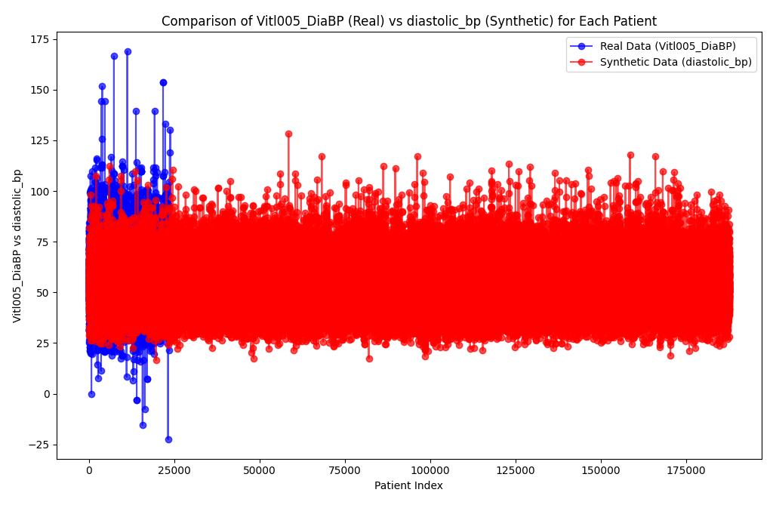

The synthetic data, by contrast, is again more tightly clustered, with fewer extreme values and less variation between patients. This reflects a limitation in the synthetic data generation model, which might be over-generalizing diastolic blood pressure values. As with systolic blood pressure, this lack of variability could reduce the synthetic data's usefulness for modeling certain health outcomes, particularly for conditions related to blood pressure abnormalities.

**4. Serum Creatinine**

Serum creatinine is a critical measure of kidney function, and its levels vary significantly depending on the patient's renal health. In the real data, there is a distinct outlier (an extremely high creatinine value), representing a patient with potentially severe renal impairment. This high variability is typical in clinical datasets, where patients with different degrees of kidney function (from healthy to critically ill) are represented.

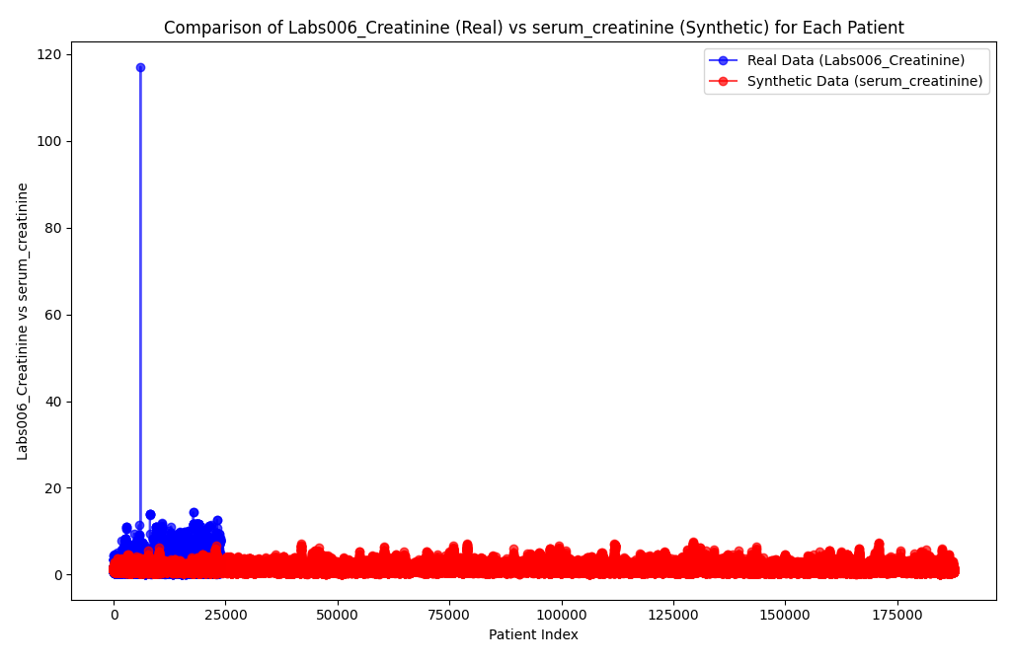

In the synthetic data, however, serum creatinine levels are much more consistent, with very few high outliers. The synthetic dataset lacks the extreme values seen in the real data, which suggests that the model generating the synthetic data might not account for patients with severe kidney dysfunction. This lack of variability in serum creatinine could be problematic in clinical applications where outlier patients are particularly important for risk assessment and treatment planning.

**5. Lactic Acid**

Lactic acid is a key marker of metabolic function, and elevated levels can indicate severe medical conditions, such as sepsis or shock. In the real dataset, there is significant variability in lactic acid levels, with some patients exhibiting very high concentrations. This reflects the diversity of health conditions in the real patient population.

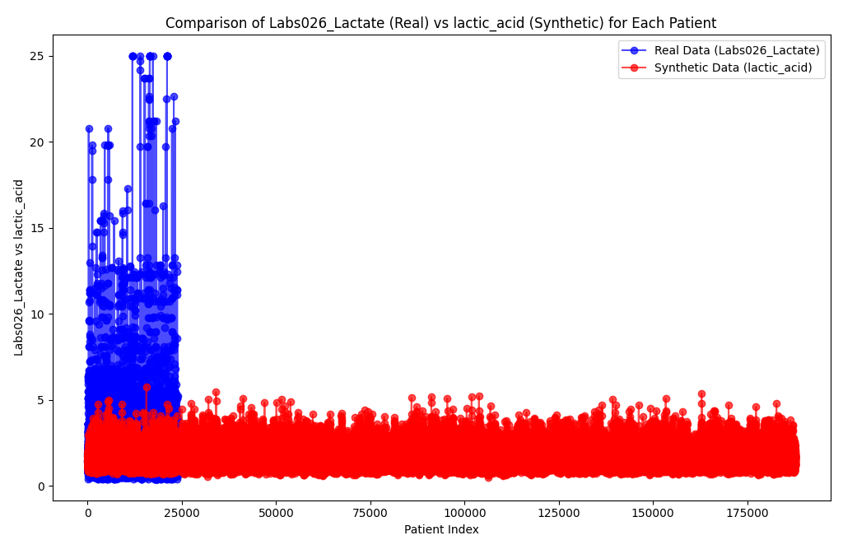

The synthetic dataset, however, shows much less variation. The lactic acid levels in the synthetic data are more uniform, with fewer patients showing high levels. This suggests that the synthetic data generation process might not accurately capture the real-world variability in lactic acid levels, particularly for patients with severe health conditions. The absence of extreme lactic acid values in the synthetic data could reduce its utility for clinical modeling, where high lactic acid levels are often associated with critical conditions.

**General Observations**

Across all the indicators, the synthetic dataset shows a consistent pattern of reduced variability compared to the real data. While the synthetic data does capture the general trends and central tendencies of the indicators, it struggles to replicate the full range of values and outliers that are seen in real-world clinical data. This lack of extreme values is particularly evident in the comparisons of serum creatinine and lactic acid, where the synthetic data misses critical outliers that could indicate severe medical conditions.

The real dataset, on the other hand, exhibits more natural variability, with a wider range of values and more outliers. This reflects the diversity of patient conditions in real clinical settings, where physiological indicators like blood pressure, serum creatinine, and lactic acid can vary widely depending on the patient's health.

**Conclusion**

In summary, while the synthetic dataset mimics many key aspects of the real data, there are noticeable differences in both the distribution of individual variables and the relationships between them. The synthetic data tends to exhibit narrower distributions and overestimates certain values, particularly for more variable or extreme values like serum creatinine and lactic acid. Additionally, the synthetic dataset does not fully capture the complex interdependencies seen in the real dataset, as evidenced by the correlation heatmaps. While synthetic data is a valuable tool for certain analyses, these results highlight the challenges in replicating real-world data complexity, particularly for medical and clinical data, where small variations and intricate relationships can be critically important.